**LAB EXERCISE – 9**

* RAMAKRISHNAN ILANGHOVAN (23BCE1489)

***CODE:***

<!DOCTYPE html>

<html lang="en">

<head>

    <meta charset="UTF-8">

    <meta name="viewport" content="width=device-width, initial-scale=1.0">

    <title>Document</title>

*<!-- <style>*

*.box {*

*display: flex;*

*justify-content: center;*

*padding: 5px;*

*}*

*.seat {*

*display: flex;*

*justify-content: center;*

*align-items: center;*

*height: 50px;*

*width: 50px;*

*color: grey;*

*border: 2px solid black;*

*margin: 2px;*

*border-radius: 10px;*

*}*

*table {*

*width: 300px;*

*height: 300px;*

*}*

*.text{*

*font-weight: 600;*

*}*

*#result{*

*width: 200px;*

*height: 20px;*

*border: 1px solid black;*

*}*

*</style> -->*

</head>

<body>

*<!-- question 1 -->*

    <table id="table" border="1">

        <tr>

            <td>Temperature</td>

            <td>Category</td>

        </tr>

    </table>

    <script src="./index.js"></script>

</body>

</html>

*// question 1*

const table = document.getElementById("table");

let temp = [55, 62, 68, 74, 59, 45, 41, 58, 60, 67, 65, 78, 82, 88, 91, 92, 90, 93, 87, 80, 78, 79, 72, 68, 61, 59, 55, 65]

for (let i = 0; i < temp.length; i++){

    if (temp[i] > 85) {

        table.innerHTML +=

            `<tr>

                <td>${temp[i]}</td>

                <td>Hot</td>

            </tr>`

    } else if (temp[i] < 60) {

        table.innerHTML +=

            `<tr>

                <td>${temp[i]}</td>

                <td>Cold</td>

            </tr>`;

    } else {

        table.innerHTML +=

            `<tr>

                <td>${temp[i]}</td>

                <td>Pleasant</td>

            </tr>`;

    }

}

***OUTPUT:***

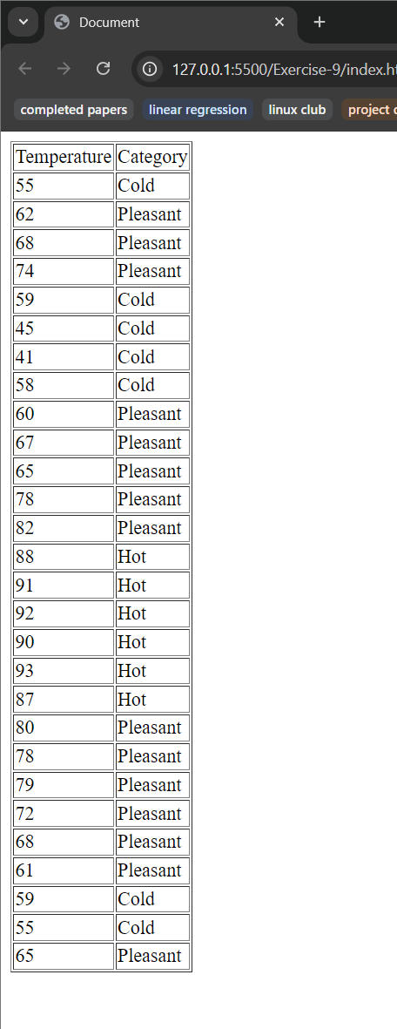

***CODE:***

<!DOCTYPE html>

<html lang="en">

<head>

    <meta charset="UTF-8">

    <meta name="viewport" content="width=device-width, initial-scale=1.0">

    <title>Document</title>

    <style>

        .box {

            display: flex;

            justify-content: center;

            padding: 5px;

        }

        .seat {

            display: flex;

            justify-content: center;

            align-items: center;

            height: 50px;

            width: 50px;

            color: grey;

            border: 2px solid black;

            margin: 2px;

            border-radius: 10px;

        }

*/* table {*

*width: 300px;*

*height: 300px;*

*}*

*.text{*

*font-weight: 600;*

*}*

*#result{*

*width: 200px;*

*height: 20px;*

*border: 1px solid black;*

*} */*

    </style>

</head>

<body>

*<!-- question 1 -->*

*<!-- <table id="table" border="1">*

*<tr>*

*<td>Temperature</td>*

*<td>Category</td>*

*</tr>*

*</table> -->*

*<!-- question 2 -->*

     <center><h1>Ticket Booking</h1></center>

     <div class="box">

        <div class="seat1 seat">1</div>

        <div class="seat2 seat">2</div>

        <div class="seat3 seat">3</div>

        <div class="seat4 seat">4</div>

        <div class="seat5 seat">5</div>

        <div class="seat6 seat">6</div>

        <div class="seat7 seat">7</div>

        <div class="seat8 seat">8</div>

        <div class="seat9 seat">9</div>

        <div class="seat10 seat">10</div>

     </div>

     <br>

    <center><button id="book">Book Tickets</button></center>

*<!-- question 3 -->*

*<!-- <center><table id="table" border="1" cellpadding="5">*

*<tr style="text-align: center;">*

*<td colspan="2">*

*<span class="text">BMI Calculator</span>*

*<select name="gender" id="gender">*

*<option value="Male">Male</option>*

*<option value="Female">Female</option>*

*</select>*

*</td>*

*</tr>*

*<tr>*

*<td colspan="2">*

*<div class="text">Enter your Weight:</div>*

*<span>(in pounds)</span>*

*<input type="text" name="" id="weight">*

*</td>*

*</tr>*

*<tr>*

*<td colspan="2">*

*<div class="text">Enter your Height:</div>*

*<span>(feet)</span>*

*<input type="text" name="" id="feet"><br><br>*

*<span>(inches)</span>*

*<input type="text" name="" id="inches">*

*</td>*

*</tr>*

*<tr>*

*<td colspan="2">*

*<center><button id="btn">Calculate</button></center>*

*</td>*

*</tr>*

*<tr>*

*<td>*

*<font size="5">YOUR BMI</font>*

*</td>*

*<td>*

*<div type="text" id="result"></div>*

*</td>*

*</tr>*

*</table></center> -->*

    <script src="./index.js"></script>

</body>

</html>

*// question 2*

const tickets = [0, 0, 0, 0, 0, 0, 0, 0, 0, 0];

let first = 1;

let second = 6;

const book = document.getElementById("book");

book.addEventListener("click", () => {

  if (first <= 5 || second <= 10) {

    const seat = prompt("enter the seat class (1 -> 1 to 5, 2 -> 6-10)");

    if (seat == 1) {

      if (first <= 5) {

          const temp = "seat" + first;

          tickets[first] = 1;

        first++;

        document.getElementsByClassName(temp)[0].style.backgroundColor = "green";

      } else {

        const temp = prompt(

          "first class is full! do you want a seat in the second class?"

        ).toLowerCase();

        if (temp === 'yes') {

          const temp = "seat" + second;

          second++;

          document.getElementsByClassName(temp)[0].style.backgroundColor = "green";

        }

      }

    } else {

      const temp = "seat" + second;

      second++;

      document.getElementsByClassName(temp)[0].style.backgroundColor = "green";

    }

  }

});

***OUTPUT:***

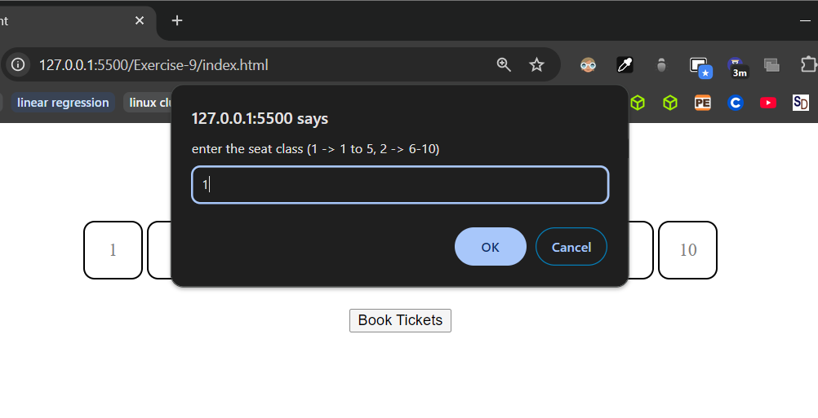

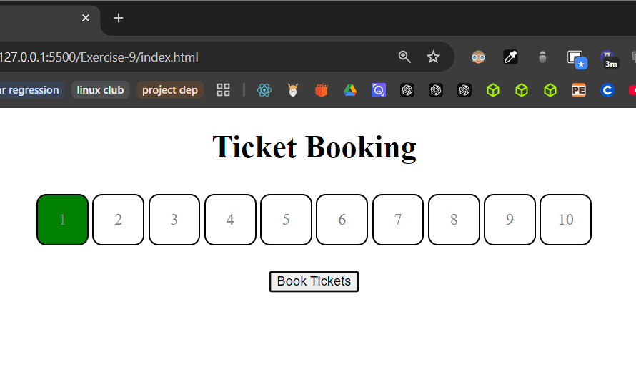 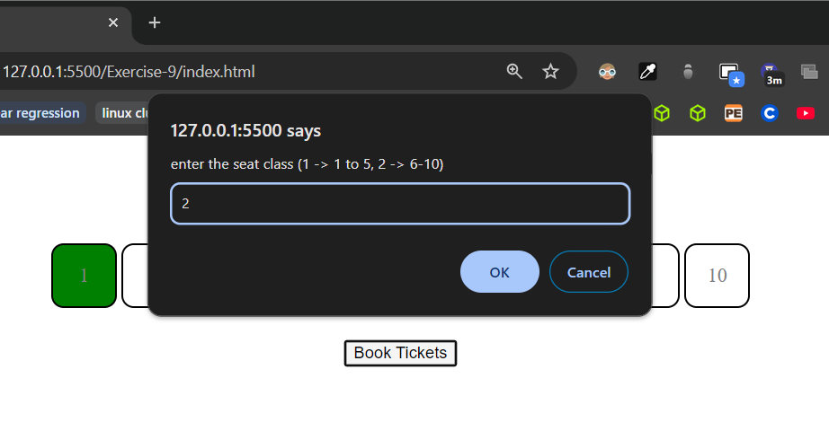 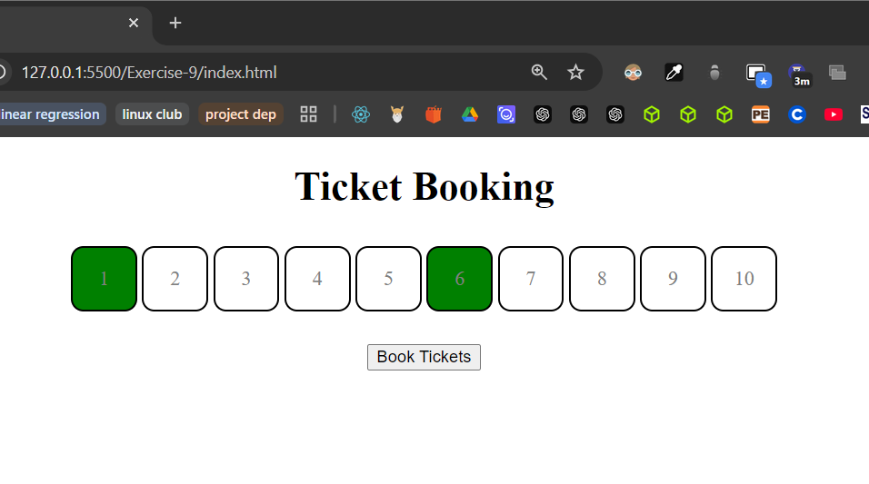

***CODE:***

<!DOCTYPE html>

<html lang="en">

<head>

    <meta charset="UTF-8">

    <meta name="viewport" content="width=device-width, initial-scale=1.0">

    <title>Document</title>

    <style>

*/* .box {*

*display: flex;*

*justify-content: center;*

*padding: 5px;*

*}*

*.seat {*

*display: flex;*

*justify-content: center;*

*align-items: center;*

*height: 50px;*

*width: 50px;*

*color: grey;*

*border: 2px solid black;*

*margin: 2px;*

*border-radius: 10px;*

*} */*

        table {

            width: 300px;

            height: 300px;

        }

        .text{

            font-weight: 600;

        }

        #result{

            width: 200px;

            height: 20px;

            border: 1px solid black;

        }

    </style>

</head>

<body>

*<!-- question 1 -->*

*<!-- <table id="table" border="1">*

*<tr>*

*<td>Temperature</td>*

*<td>Category</td>*

*</tr>*

*</table> -->*

*<!-- question 2 -->*

*<!-- <center><h1>Ticket Booking</h1></center>*

*<div class="box">*

*<div class="seat1 seat">1</div>*

*<div class="seat2 seat">2</div>*

*<div class="seat3 seat">3</div>*

*<div class="seat4 seat">4</div>*

*<div class="seat5 seat">5</div>*

*<div class="seat6 seat">6</div>*

*<div class="seat7 seat">7</div>*

*<div class="seat8 seat">8</div>*

*<div class="seat9 seat">9</div>*

*<div class="seat10 seat">10</div>*

*</div>*

*<br>*

*<center><button id="book">Book Tickets</button></center> -->*

*<!-- question 3 -->*

     <center><table id="table" border="1" cellpadding="5">

        <tr style="text-align: center;">

            <td colspan="2">

                <span class="text">BMI Calculator</span>

                <select name="gender" id="gender">

                    <option value="Male">Male</option>

                    <option value="Female">Female</option>

                </select>

            </td>

        </tr>

        <tr>

            <td colspan="2">

                <div class="text">Enter your Weight:</div>

                <span>(in pounds)</span>

                <input type="text" name="" id="weight">

            </td>

        </tr>

        <tr>

            <td colspan="2">

                <div class="text">Enter your Height:</div>

                <span>(feet)</span>

                <input type="text" name="" id="feet"><br><br>

                <span>(inches)</span>

                <input type="text" name="" id="inches">

            </td>

        </tr>

        <tr>

            <td colspan="2">

                <center><button id="btn">Calculate</button></center>

            </td>

        </tr>

        <tr>

            <td>

                <font size="5">YOUR BMI</font>

            </td>

            <td>

                <div type="text" id="result"></div>

            </td>

        </tr>

     </table></center>

    <script src="./index.js"></script>

</body>

</html>

*// question 3*

const btn = document.getElementById("btn")

btn.addEventListener("click", () => {

    const weight = document.getElementById("weight").value;

    const feet = document.getElementById("feet").value;

    const inches = document.getElementById("inches").value;

    const gender = document.getElementById("gender").value;

    const bmi = 703 * (weight / Math.pow(feet || inches, 2))

    document.getElementById("result").textContent = bmi;

    if (bmi < 17.5) {

      alert("Anorexia");

    } else {

      if (gender == "Male") {

        if (bmi > 17.501 && bmi < 20.7) {

          alert("Underweight");

        } else if (20.71 < bmi && bmi < 26.4) {

          alert("Ideal Range");

        } else if (26.41 > bmi && 26.4 < bmi) {

          alert("Marginally Overweight");

        } else if (bmi > 27.81 && bmi < 31.1) {

          alert("Overweight");

        } else {

          alert("Very Overweight or Obese range");

        }

      } else if (gender == "Female") {

        if (bmi > 17.501 && bmi < 19.1) {

          alert("Underweight");

        } else if (19.11 < bmi && bmi < 25.8) {

          alert("Ideal Range");

        } else if (25.81 > bmi && 27.3 < bmi) {

          alert("Marginally Overweight");

        } else if (bmi > 27.31 && bmi < 32.3) {

          alert("Overweight");

        } else {

          alert("Very Overweight or Obese range");

        }

      }

    }

})

***OUTPUT:***

